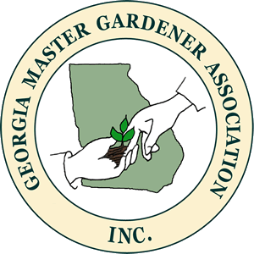
Georgia Master Gardener Association Award of Excellence

For Outstanding Support for
Georgia Master Gardener Extension Volunteers

2024 Entry Form
Deadline 1 September 2024

Name

(If selected, how do you prefer your name on your certificate?)
Address |  | County
City | State: GA | Zip
Phone # | Cell # | FAX #
E-mail Address:

My signature verifies that I am a member of the Georgia Association of County Agriculture Agents with an active GAMGEV program.

Signature Date _

Applicant shall submit photo, biography and sign the Media Release form attached to the Entry Form.

Recipient must commit to attending both the Georgia Master Gardener Association Conference on October 5, 2024
and the Georgia Association of County Agriculture Agents annual meeting which is Nov ?, 2024

Send completed application to Sheri Dorn, Consumer Horticulture Extension Specialist and State MGEV Program Coordinator, at sdorn@uga.edu no later than 11:55 p.m. on 1 September 2024.

Recipients will be notified by 18 September 2024.

- Entries will be initially evaluated by a team of agents and GMGA representatives.
- Applicant must be a member of GACAA in the year of submission and coordinating an MGEV program.
- Applicants must commit to attend both the GMGA Conference on 5 October, 2024
in Griffin and the GACAA Nov 13-14 on Jekyll Island, GA in the event they are the winner.

ENTRY AND JUDGING CRITERIA

- List the consumer projects in the organization that has provided leadership during the last 12 months.

- Describe the ANR involvement in the GMGA training program in the local organization and other area groups,

- What has the local MGEV group done in the last 12 months that makes them stand out as a result of the leadership shown from this Extension Office.

- How is regular communication and promotion of accomplishments handled?

AWARD

The winner will receive recognition at the GMGA annual conference and the GACAA annual meeting. The recipient is requested to share with GMGA by speaking biefly at the annual conference, meeting with the GMGA Board, and/or writing an article for the GMGA newsletter.

GMGA will provide the winner with one night's lodging on the night prior to the GMGA Conference to accommodate winner's presence at the GMGA Conference on October 5, 2024.

JUDGING PROCESS

- Applicants cannot be members of the judging team
- Judging Team – three (3) GMGA MGEV representatives and two ( 2) non-MGEV members of the Advisory Panel
- Notification of the Award criteria and Application form will be made available no later than 1 June 2024.
- Deadline date for submission 1 September 2024 11:55 PM
- Winner to be notified by 18 September 2024.

